The User Manual

The Login page:
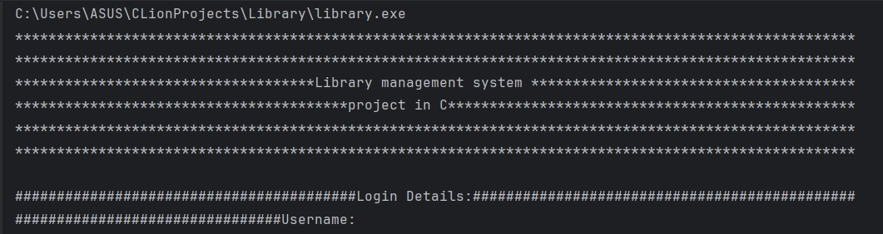
The Student username is basically the student email, the student email is found in the ‘studentList.txt’.
To be noted: All students have a Universal password which is “unmc_lms”.
When using the correct Student Username and Student password:
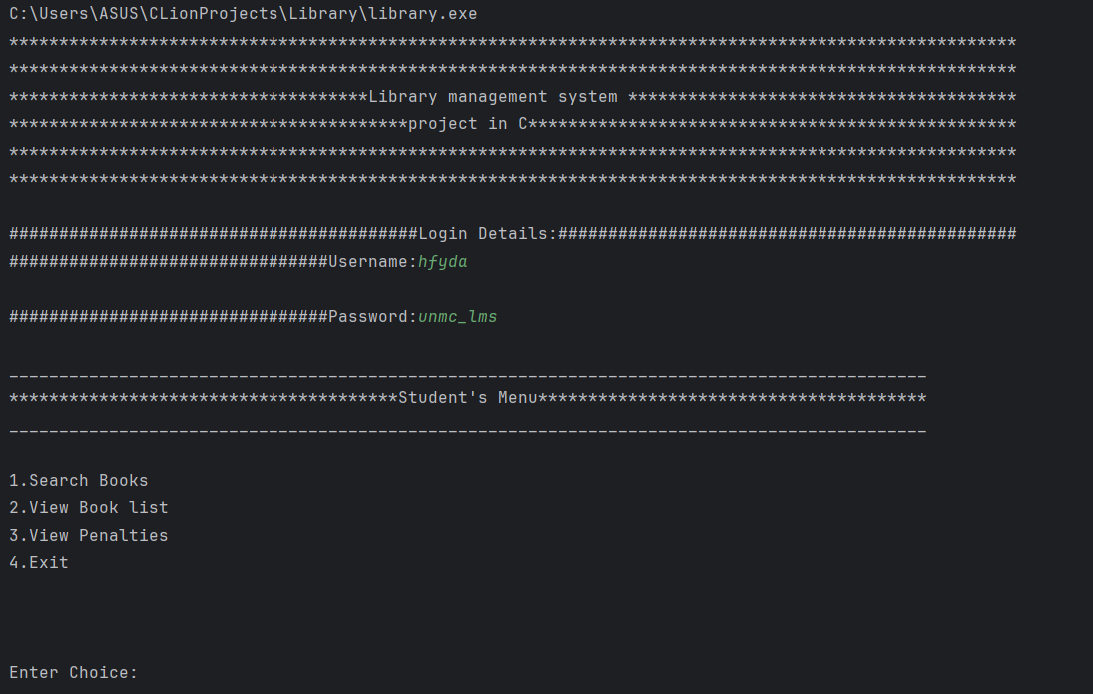

When the Student wants to search for books:
The Student hfyda is asked for the ISBN number.
Then, the program displays the book.
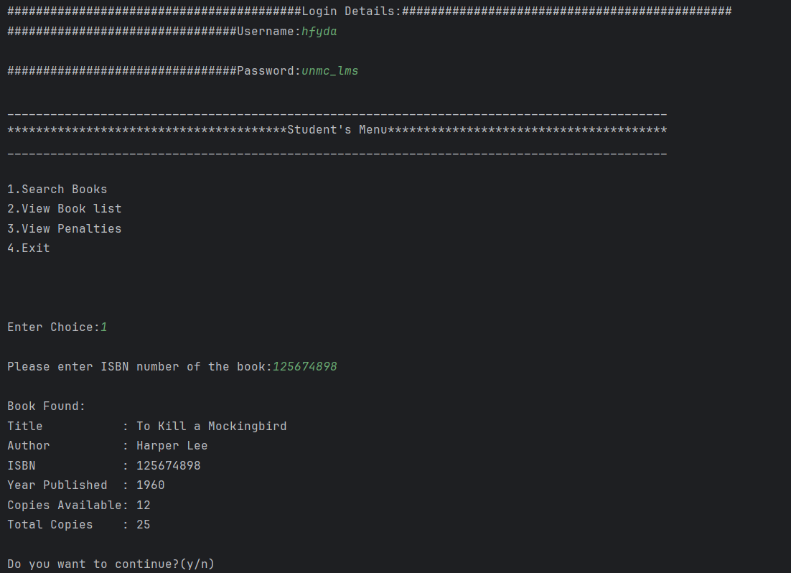

Then, Student hfyda inputs ‘n’ to log out out from the program.
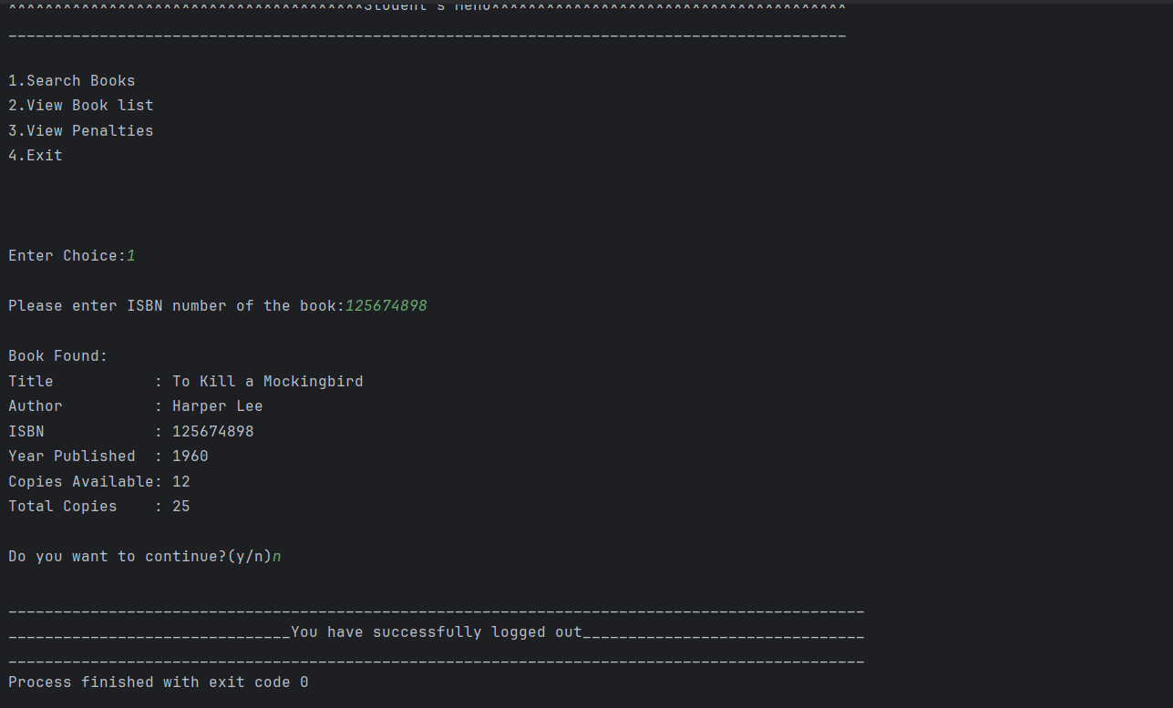
When the Student hfyda wants to view the Book List:
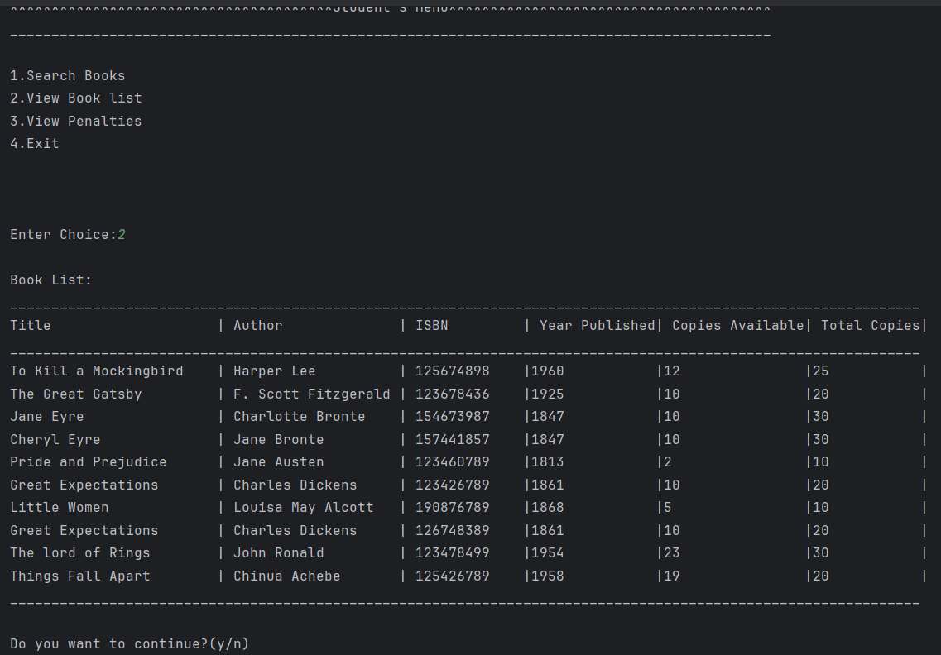

When the student hfyda wants to view the student’s penalties:
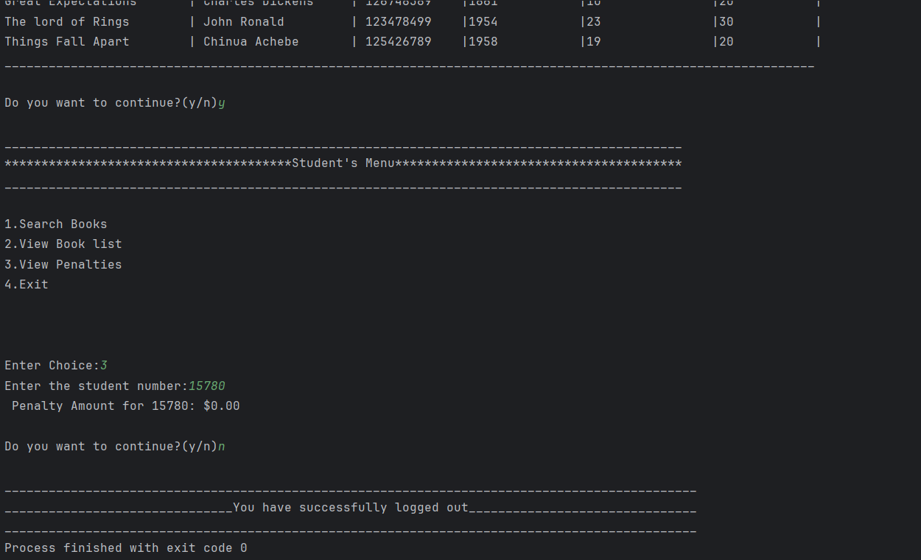
When the Student hfyda wants to exit the program from the Students Menu:
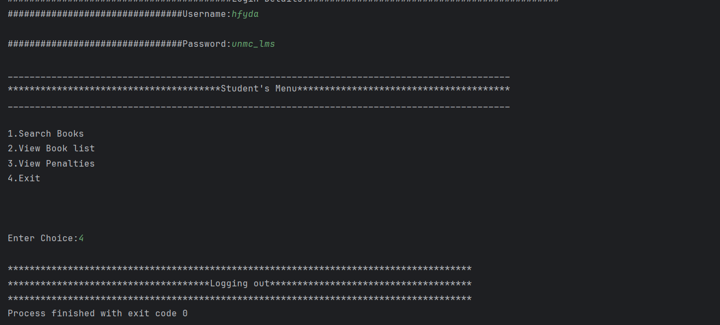

When the Student wants to access the Student’s Menu again after getting a result:
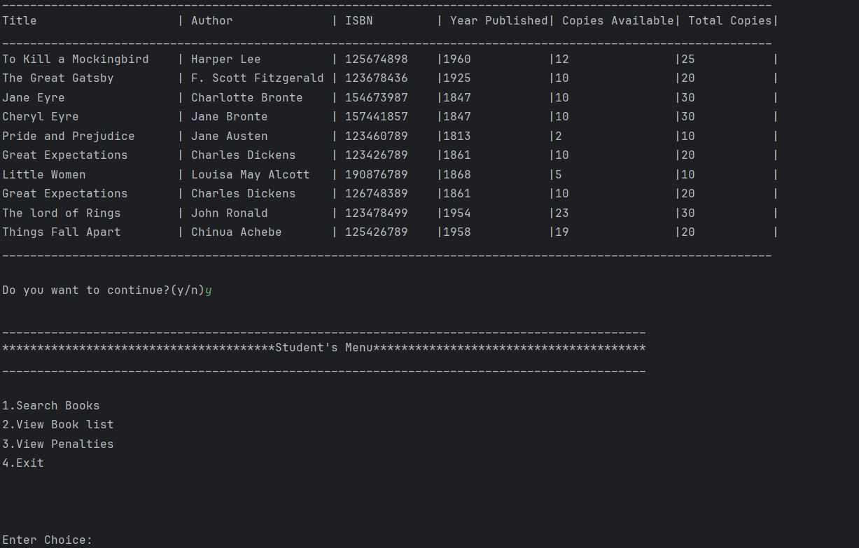
The Librarian username is basically the librarian email, the librarian email is found in the ‘librarianList.txt’.
When Librarian lyiemy enters the valid username and password:
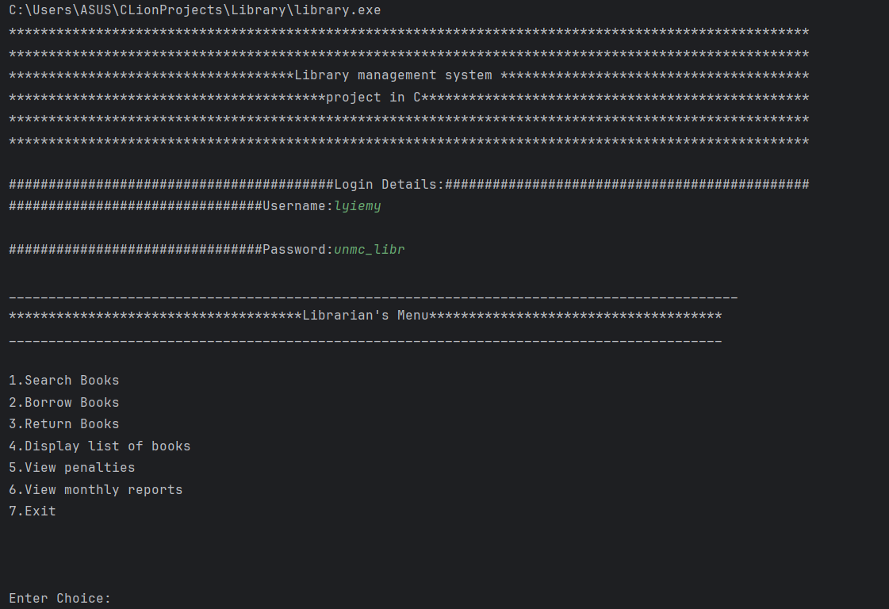

When the Librarian wants to search for books:

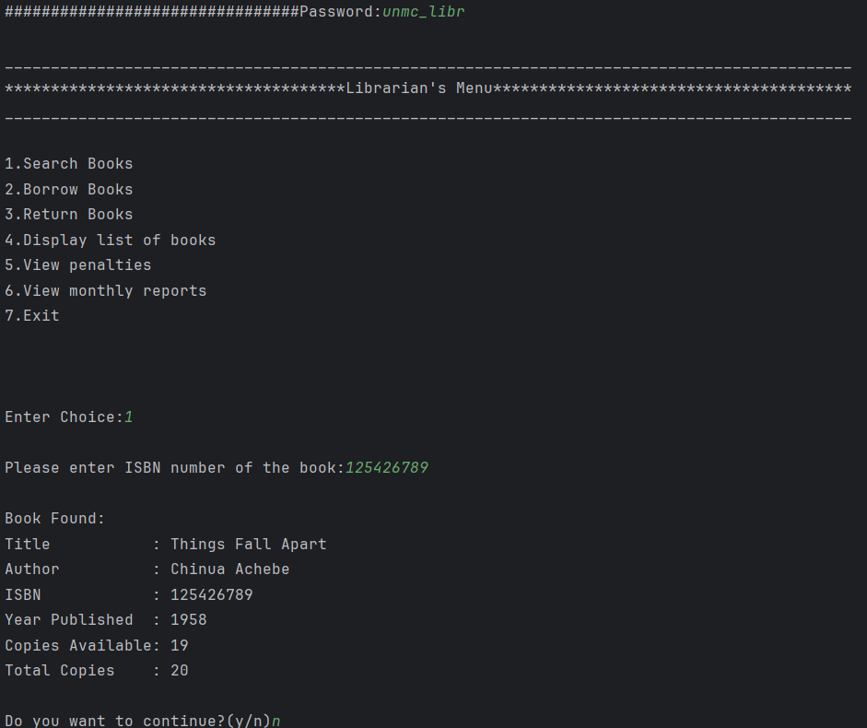

When Librarian wants to enter the borrow transaction for Student 15780(bookList.txt is modified accordingly):
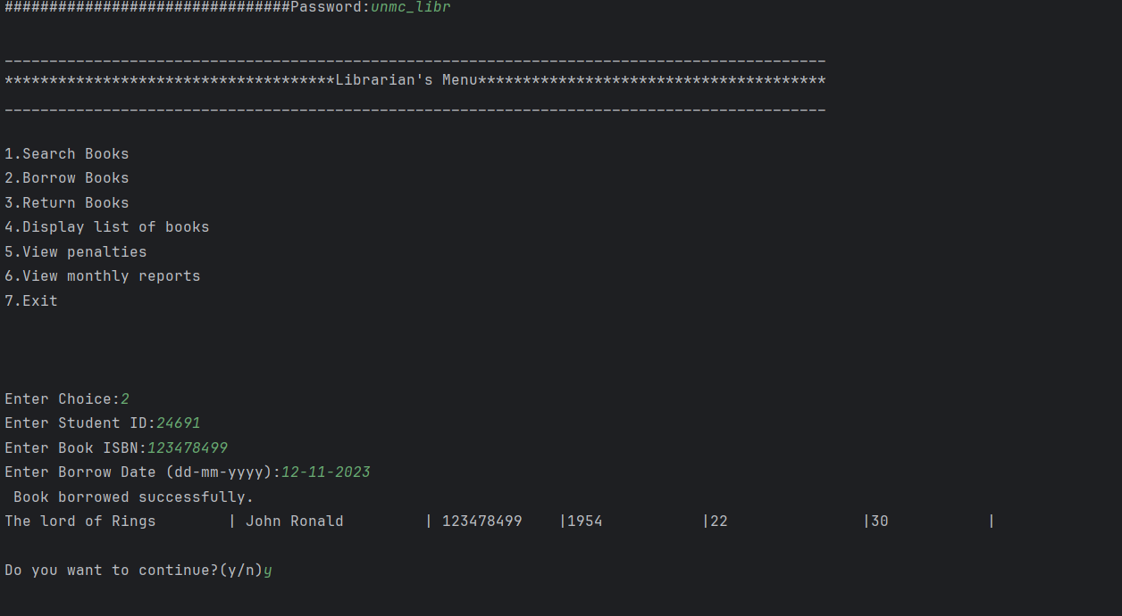

When Librarian wants to enter the return transaction for student 15780(bookList.txt is modified accordingly):
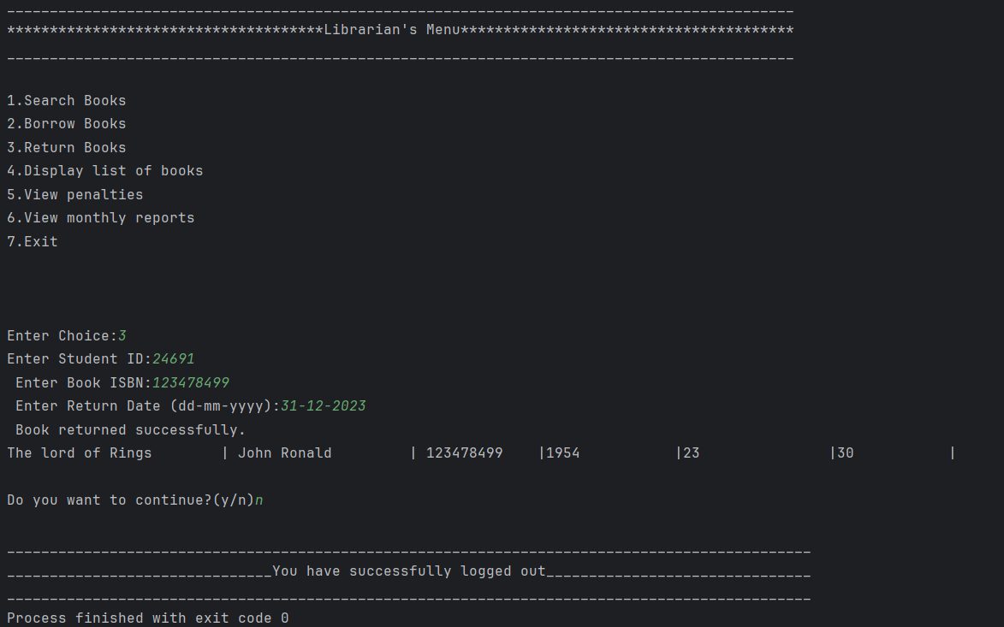

When book is returned, the penalty will be calculated and added to the penaltyList.txt:
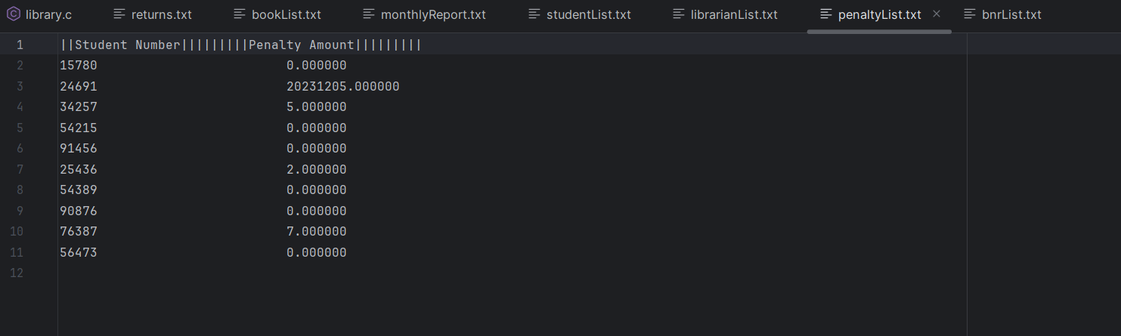

This below is the bnrList.txt where the borrow transaction was saved:
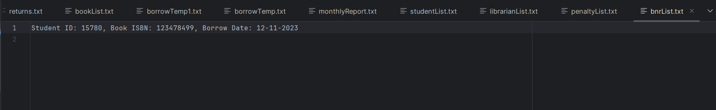
This below is the returns.txt where the return transaction was saved:
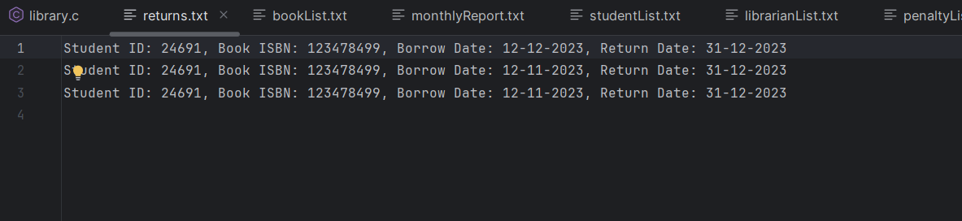

When the Librarian wants to read the List of All Books:
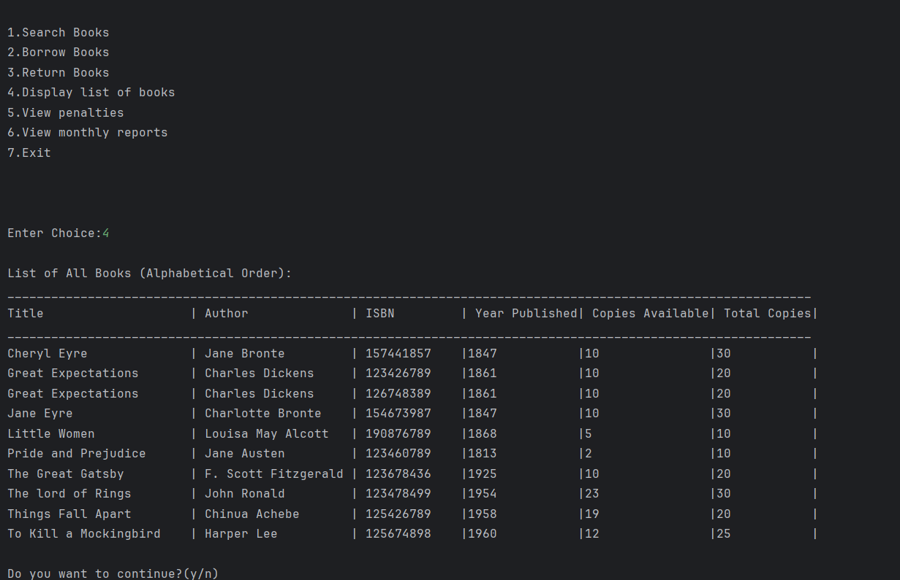

When the Librarian wants to read the list of penalties for all students:
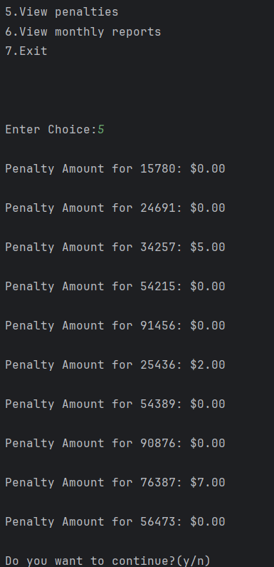

When the Librarian wants to read the Monthly Report:
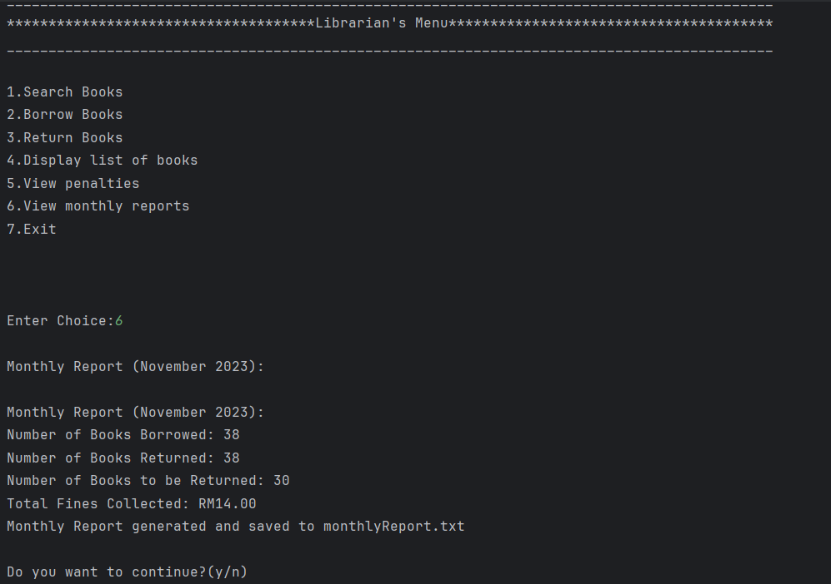

When the Librarian wants to log out of the Librarian’s Menu:
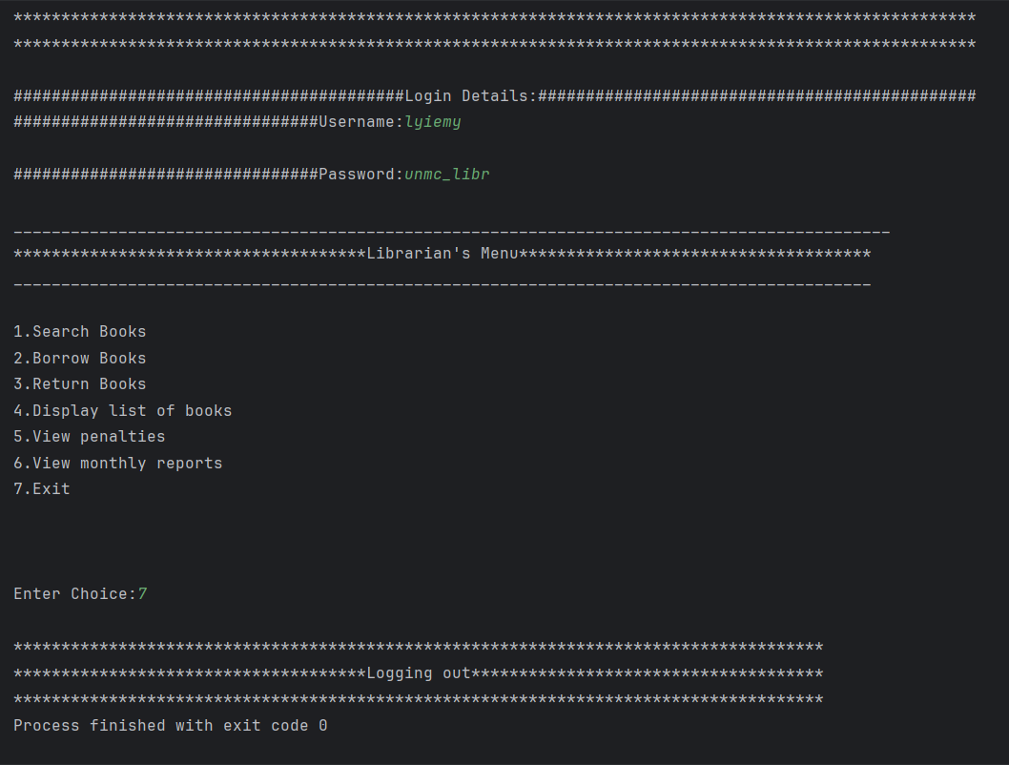

This is the display for the Penalty List saved as penaltyList.txt:
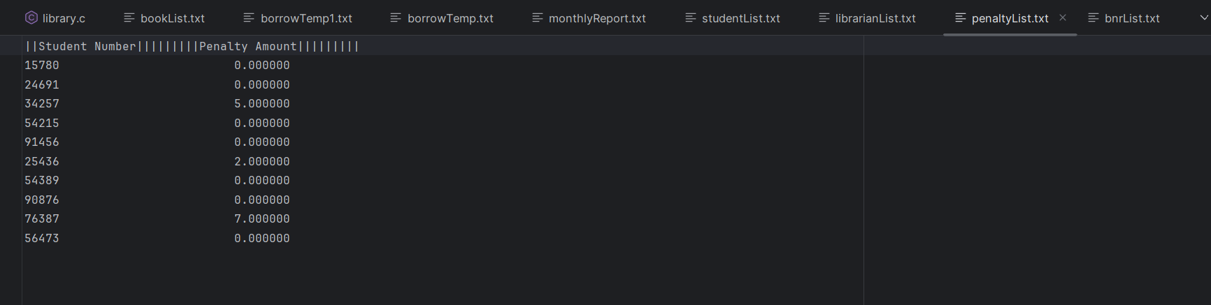

This is the display of the Student List saved as the studentList.txt:
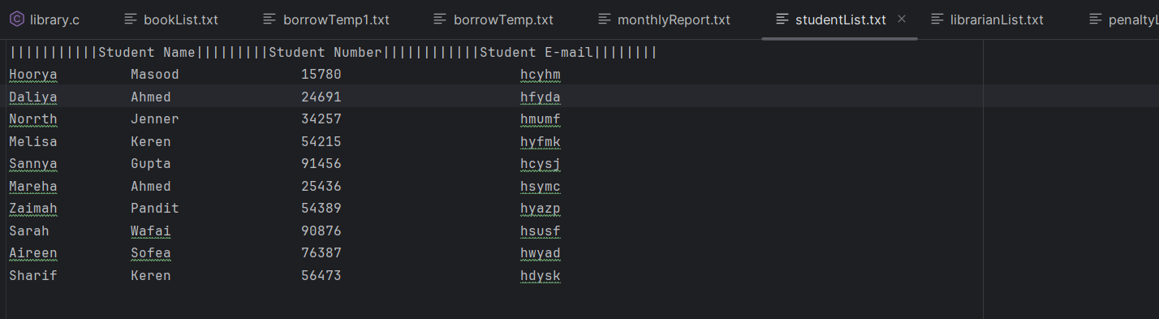
This is the display of the Book List saved as the bookList.txt:
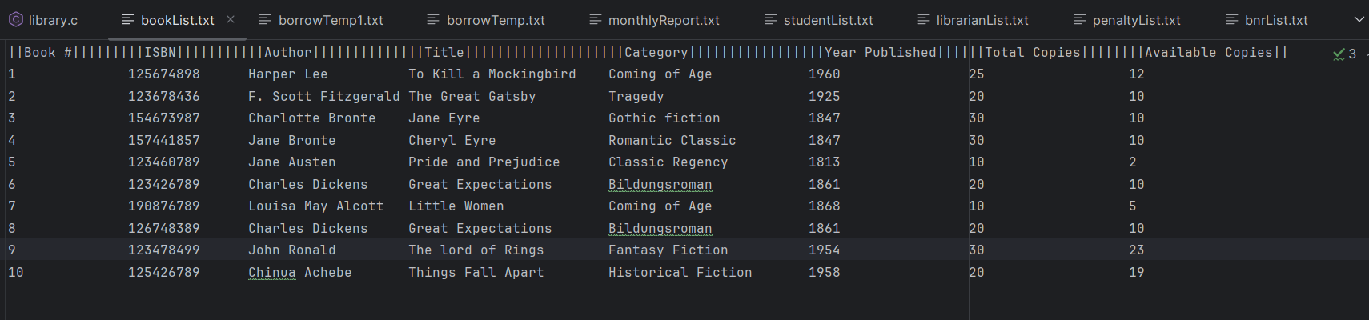
This is the display of the Monthly Report saved as the monthlyReport.txt:
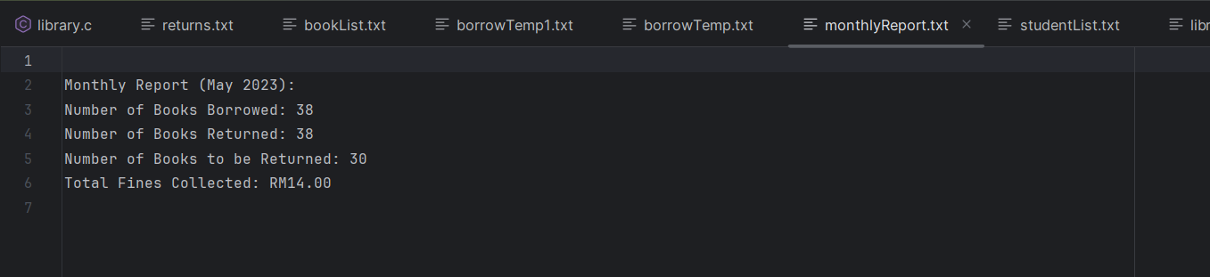

This is the display of the Librarian List saved as the librarianList.txt:
